BROWN YOUTH INITIATIVE
PARTNER APPLICATION

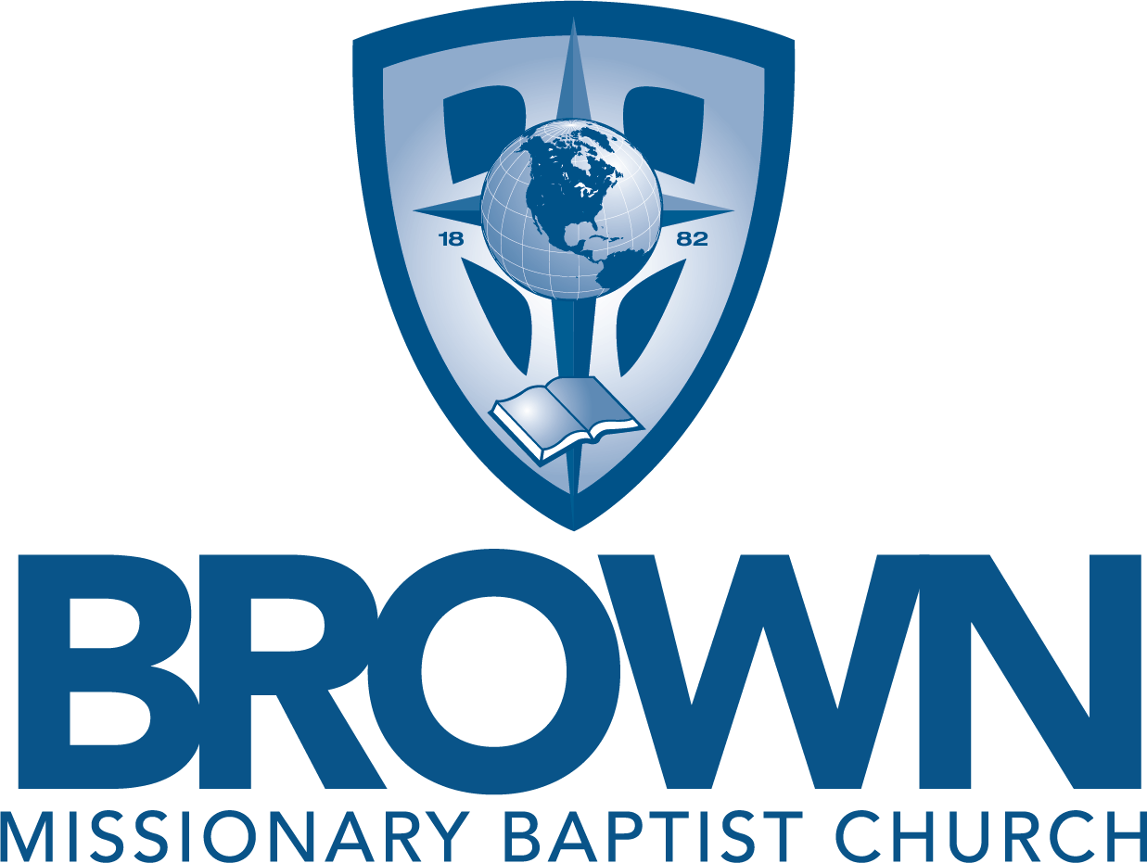

Pastor Bartholomew Orr

Brown Youth Initiative
2024

ACTS Career Center
880 Stateline Road East, Annex Building 3
Southaven, MS 38671
Phone: 662.796.2287
byi@brownbaptist.org
www.actscareercenter.org

Dear Prospective Partner,

Brown Missionary Baptist Church exists to Exalt Our Savior through inspiring and informative worship, to Edify the Saints through biblical teaching, to Evangelize the Sinners through faithful witness, and to Exhibit Godliness through a positive presence in our community.

The Brown Youth Initiative Program is committed to the values of our mission. The goal of the Brown Youth Initiative is to give students ages 15 – 20 an opportunity to develop job skills while enhancing their education and community relations.

The principles include engaging the talents and interests of youth, developing their skills and competence, and providing positive adult role models. The BYI experience introduces youth to the workplace, imparts valuable employment skills, and provide youth with a summer income. The objectives of the BYI Youth Initiative are to:

- Emphasize real-world labor expectations
- Increase awareness of services offered by local community-based organizations
- Provide opportunities for career instruction, financial literacy training, academic improvement, and social growth
- Enhance basic academic, occupational, and other skills necessary for youth to obtain and maintain long-term employment.
- Help youth make a smooth transition from school to career and/or higher education.
The Brown Youth Initiative is a four-week program that will begin June 3rd through June 28th. Participants are allowed to work a maximum of 120 hours during the four-week program at the rate of $8.50. Payments are processed through the ACTS Career Center and distributed on a bi-weekly basis.

Although all salaries are funded by Brown Baptist Church, we do ask for a $250 donation made payable to ACTS Career Center from each partner to assist with funding youth programs.

WE NEED YOUR HELP. We are looking for businesses to collaborate with us to provide a mentoring and employment placement experience for youth. If you are interested, please complete the enclosed partner application, and return to:

ACTS Career Center, Inc
880 Stateline Rd. E, Annex Building 3
Southaven, MS 38671
662.796.2287
Or email to byi@brownbaptist.org

Brown Youth Initiative Participation Requirements
The selection of each youth is based upon the following criteria:
- Participant must be between 15 and 20 years of age and must be enrolled in school.
- Participation in the BYI Program cannot exceed three years.
- Participant must submit two letters of reference.
- Participant must be in good academic standing (High School or College) with a 2.0 GPA or higher.
- Participant must not exceed 120 work hours within program dates
2024 Program Dates: June 3rd – June 28th (4 weeks)

- Hours & Pay: Up to 120 hours during the 4-week program,
Any days of the week: preferably not on Sunday

- Wage $8.50 per hour Stipend

- Eligibility: Ages 15 through 20

- Suggested Internships:
Clerical, filing, office work.
Customer service
Educational, childcare
Recreational
Music and Arts
Computers, web-design, multi-media, technology
Community service
Health and Science
Fitness
Other Professional Mentoring

Brown Youth Initiative Partner Application
Brown Missionary Baptist Church

Applicant Information
Legal Business Name:
(As Registered with Internal Revenue Service)
Address:
 |  |  | Street Address of Place of Employment |  |  |  |  |  |  |  |  |  |  |  | Suite/Unit #
 |  |  | City |  |  |  |  |  |  |  |  |  |  | State | ZIP Code
Contact Phone: |  |  |  |  |  |  |  |  | Email Address:
Contact/ Supervisor Name:
Type of Business :

Position Information
Please provide a brief description and duties of the positions listed above.
Please list additional requirements:

We do request that you consider submitting a $250 donation made payable to ACTS Career Center to assist with funding youth programs.

